Seitenov Altynbek
Senior lecturer, School of Software Engineering
Astana IT University, Kazakhstan
Email: altynbek.seitenov@astanait.edu.kz
Orcid: 0000-0001-5777-436
Akhmedali Duisembaiuly
Bachelors degree, School of Software Engineering
Astana IT University, Kazakhstan
Email: 230404@astanait.edu.kz
Zhanserik Gaziz
Bachelors degree, School of Software Engineering
Astana IT University, Kazakhstan
Email: 231772@astanait.edu.kz
Adilbek Zhalgassov
Bachelors degree, School of Software Engineering
Astana IT University, Kazakhstan
Email: 231728@astanait.edu.kz
Merey Mynbayev
Bachelors degree, School of Software Engineering
Astana IT University, Kazakhstan
Email: 230173@astanait.edu.kz
Damir Kairlbay
Bachelors degree, School of Software Engineering
Astana IT University, Kazakhstan
Email: 230579@astanait.edu.kz

Permissioned Blockchain-Based System for Secure Exchange of Medical Data and Clinical Conclusions

Abstract: The increasing digitalization of healthcare drives the need for secure, transparent, and interoperable mechanisms for exchanging medical data among institutions. Conventional centralized electronic health record (EHR) systems are vulnerable to data breaches, limited interoperability, and insufficient patient control over personal information. This study analyzes and designs a hybrid permissioned blockchain architecture based on Hyperledger Fabric and R3 Corda, integrated with HL7 FHIR standards, to enable secure interactions between healthcare organizations. The research employs a mixed-methods approach, including a systematic literature review, quantitative surveys of cybersecurity and medical specialists and students, and testing of a functional prototype in compliance with GDPR and HIPAA requirements. Results demonstrate strong professional endorsement of the proposed architecture and confirm its effectiveness in enhancing privacy, governed access, transparency, and scalability relative to centralized or single-framework solutions. Special focus is placed on differing priorities and perceptions among professional and trainee stakeholders in medicine and technology, highlighting the importance of a multidisciplinary approach to digital healthcare system design. The presented system shows significant potential for comprehensive medical data protection while improving convenience and trust across all ecosystem participants. The main study limitation is the small sample size; future work will address scaling and integration with real health information systems to assess reliability and practical efficacy.
Keywords: Permissioned Blockchain; R3 Corda; Medical Data Exchange; Hyperledger Fabric; Electronic Health Records (EHR); Interoperability; Data Privacy; GDPR Compliance; HL7 FHIR; Patient Consent Management

Introduction
The increasing reliance on digital healthcare systems has heightened the demand for secure, transparent, and interoperable mechanisms for exchanging medical data. Traditional Electronic Health Record (EHR) infrastructures are often highly centralized, resulting in persistent vulnerabilities such as data breaches, interoperability challenges, and insufficient patient control over personal information [1]. Permissioned blockchain technologies, including Hyperledger Fabric and R3 Corda, provide decentralized governance, immutable records, and controlled access, positioning them as viable solutions for healthcare applications [2], [3]. These frameworks restrict participation to authenticated entities, such as hospitals, laboratories, and insurers, thereby enhancing data confidentiality and traceability [7], [8]. However, the integration of hybrid architectures that combine multiple permissioned blockchains while adhering to standards like the General Data Protection Regulation (GDPR), Health Insurance Portability and Accountability Act (HIPAA), and HL7 Fast Healthcare Interoperability Resources (FHIR) remains underexplored [4], [5].
Key concepts in this domain include blockchain, a distributed ledger technology that ensures data integrity through cryptographic hashing and consensus mechanisms; permissioned blockchain, which differs from public variants by requiring identity verification for participants; Hyperledger Fabric, a modular framework supporting private channels and Private Data Collections (PDCs) for off-chain storage of sensitive data; and Corda, which emphasizes point-to-point transactions for enhanced privacy [7]–[9]. Recent studies highlight Fabric's effectiveness in multi-party collaborations, as demonstrated in an IBM and Mayo Clinic pilot where it reduced data exposure by 70% compared to centralized EHRs [8]. In contrast, Corda excels in bilateral exchanges, processing transactions with lower latency (0.4 s versus Fabric's 0.8 s) while preventing double-spending via notaries [8], [9]. Real-world implementations like hChain 4.0 (using Corda) reduced duplicated data entry by 45%, and ACTION-EHR (based on Fabric) enabled patient-managed oncology records [8], [11].
Debates in the field center on data storage models, with full on-chain storage conflicting with GDPR's "right to erasure," leading to hybrid approaches where only hashes and metadata are stored on-chain, and actual data resides in encrypted off-chain repositories like IPFS or AWS S3 [12]. Encryption standards such as AES-256 for symmetric protection and RSA-2048 or Attribute-Based Encryption (ABE) for key management have proven effective in maintaining compliance without sacrificing integrity [11]. Interoperability issues arise from heterogeneous EHR formats, addressed through FHIR integration and Decentralized Identifiers (DIDs) for standardized data exchange [13]. Scalability concerns persist, with Fabric's ordering service potentially bottlenecking under high loads, while Corda's design avoids broadcasting but complicates multi-party synchronization [10].
This research addresses critical gaps in existing knowledge, including limited hybrid evaluations of Fabric and Corda, inadequate patient consent management via FHIR, and scarce empirical data on stakeholder trust [6], [12]–[14]. The problem of data fragmentation, privacy risks, and poor interoperability in healthcare is significant because it impedes efficient clinical decision-making, increases breach vulnerabilities, and hinders compliance with global standards, ultimately affecting patient outcomes in a field where timely and secure data sharing is essential. This work applies to the broader domain of blockchain in healthcare by proposing a hybrid model that balances privacy, efficiency, and scalability, contributing to digital transformation initiatives.
The main objective is to analyze and design a hybrid blockchain architecture combining Hyperledger Fabric and Corda for secure interactions among medical institutions, implementing data management protocols with GDPR compliance and AES-256 hashing. The hypothesis posits that this hybrid permissioned model will enhance security, scalability, and interoperability compared to centralized or single-framework systems, as evidenced by improved consent management, reduced latency, and stakeholder acceptance. To investigate this, the study employs a mixed-methods approach: a systematic literature review to identify limitations, a stratified survey of cybersecurity and medical students/professionals to analyze perceptions, architectural design integrating Fabric's channels with Corda's point-to-point model and FHIR APIs, a prototype validation illustrating data flow and access controls, and evaluation of real-world feasibility.
Theoretically, this study advances understanding of hybrid blockchain models for patient-centric governance; practically, it offers a scalable framework for transparent data sharing, with main findings indicating strong professional support for the hybrid system's effectiveness in addressing privacy and interoperability challenges.

Literature review
Recent advancements in blockchain technology have introduced decentralized and secure management of medical information in healthcare. Permissioned blockchain architectures, such as Hyperledger Fabric, and Corda, are reliable for environments requiring identity control, data confidentiality, and traceability, allowing only authenticated participants—such as hospitals, laboratories, and insurers—to interact [7], [8]. Hyperledger Fabric employs a modular, channel-based architecture that enables private communication among selected participants, with Private Data Collections (PDCs) keeping sensitive records off-chain while verifying integrity through on-chain hashes. An IBM and Mayo Clinic pilot study (2024) showed Fabric reducing data exposure by approximately 70% compared to centralized EHR systems, as each hospital node accesses only channel-specific information [8]. Corda, in contrast, uses a point-to-point transaction model, sharing data only among involved parties for higher privacy and legal accountability. Lin et al. [9] confirmed Corda’s notary service prevents double-spending and achieves consensus without broadcasting medical information, with empirical tests by Gupta et al. [8] indicating an average latency of 0.4 s versus 0.8 s for Fabric under similar conditions. Both support smart contracts for access control, consent management, and audit trails; Corda suits bilateral institutional transactions, while Fabric excels in multi-party collaborations. Implementations like hChain 4.0 (Corda-based) reduced duplicated data entry by 45% [8], and ACTION-EHR (Fabric-based) enabled patient-managed oncology records [11].
Key debates focus on data storage models, where full on-chain storage provides immutability but conflicts with GDPR’s “right to erasure,” leading most solutions to hybrid approaches with metadata, hashes, and permissions on-chain, and actual data in encrypted off-chain storage (e.g., IPFS or AWS S3) [12]. Encryption relies on AES-256 for symmetric protection and RSA-2048 or Attribute-Based Encryption (ABE) for key management, as demonstrated in ACTION-EHR and MedRec 2.0 for improved scalability and compliance [11]. Interoperability challenges arise from heterogeneous EHR formats, addressed via FHIR and Decentralized Identifiers (DIDs) for consistent, secure data retrieval without exposing identifiers [13]. Scalability issues include Fabric’s ordering service bottlenecking under heavy loads and Corda’s synchronization challenges in multi-party scenarios; Kumar et al. [10] suggest multi-chain hybrid architectures for balancing privacy, efficiency, and scalability.
Despite progress, gaps persist: EHR integration requires complex middleware for incompatible hospital databases [14]; identity management needs unified patient standards beyond promising DIDs [13]; network governance remains unclear among governmental, consortia, or private operators [12]; data availability risks “orphaning” off-chain files, mitigated by IPFS pinning, backups, and Zero-Knowledge Proofs (ZKPs) [12]; and hybrid Fabric-Corda evaluations are mostly isolated, lacking real-world integration [6].
To address these, this research proposes a hybrid permissioned blockchain architecture integrating Hyperledger Fabric for multi-party collaboration and Corda for peer-to-peer sharing. Patient data—diagnoses, results, prescriptions, and conclusions—is encrypted locally, hashed, and linked to transactions, with smart contracts and FHIR-compliant APIs governing access via hardware-secured keys. This achieves balance in privacy, interoperability, and scalability, filling gaps in governance, compliance, and deployment for healthcare blockchain systems.

Methods and Materials
  - Data Collection Tools
This study employed a mixed-methods sequential explanatory design to investigate the feasibility, security, and stakeholder acceptance of a hybrid permissioned blockchain system for healthcare data exchange. The research was conducted in two phases: (1) a quantitative phase involving a structured online survey to measure perceptions, awareness, and acceptance across stratified professional groups, and (2) a qualitative phase comprising the design and development of a functional system prototype to visualize technical implementation and architectural feasibility. This mixed-method structure supports triangulation and complementarity, strengthening the validity and practical applicability of the findings [26].
  - Sampling Strategy
This study employs stratified sampling to capture perspectives from cybersecurity and medicine domains, including students and professionals in each. Cybersecurity participants provide technical expertise in data protection, encryption, and access control, while medical participants address clinical workflows, ethical implications, and healthcare data constraints. The population is divided into four strata: (1) Cybersecurity students (undergraduate/graduate in cybersecurity or IT security); (2) Cybersecurity professionals (lecturers, researchers, industry practitioners); (3) Medical students (in medicine or biomedical/health informatics); (4) Medical professionals (clinicians, informatics specialists, healthcare IT staff, researchers). This approach ensures balanced representation, minimizes bias, and enables comparative analysis between domains (cybersecurity vs. medical) and within domains (students vs. professionals) on security, usability, and interoperability in blockchain-based healthcare systems. Stratified sampling is suitable for heterogeneous subgroups with distinct knowledge [17], enhancing validity and reliability over simple random sampling [15], [16]. It provides insights into the feasibility, security, and ethical readiness of permissioned blockchain for medical data exchange.
  - Quantitative Approach
The quantitative approach aims to measure differences in perceptions, awareness, and acceptance of permissioned blockchain systems among four respondent groups: cybersecurity students, cybersecurity professionals, medical students, and medical professionals. This structured approach uses measurable variables derived directly from survey questions to identify relationships between technical expertise, professional domain, and attitudes toward blockchain security, privacy, and usability.

Role of Variables
- Independent variables: define strata (domain and role) and prior experience, allowing comparative and subgroup analysis.
- Dependent variables: capture outcome perceptions — trust, acceptance, ethical judgment, and perceived risk. This structure enables statistical testing (e.g., mean comparison between strata) to determine whether technical expertise or medical context more strongly influences attitudes toward blockchain adoption.
Measurement of Variables
- Ordinal Variables: 5-point Likert scales (from Strongly Disagree to Strongly Agree) are used to measure intensity of opinions and attitudes, which allows ranking without assuming equal intervals [23], [24].
- Nominal Variables: Multiple-choice questions classify respondents and their preferences (no inherent ranking) [25].
  - Qualitative tool
Software Design
The software design of the proposed permissioned hybrid blockchain system was developed as a functional Figma prototype to visualize how secure data exchange and governance operate between medical institutions. The interface demonstrates the integration of blockchain architecture (Hyperledger Fabric + Corda) with user-centered workflows, ensuring privacy, transparency, and interoperability.
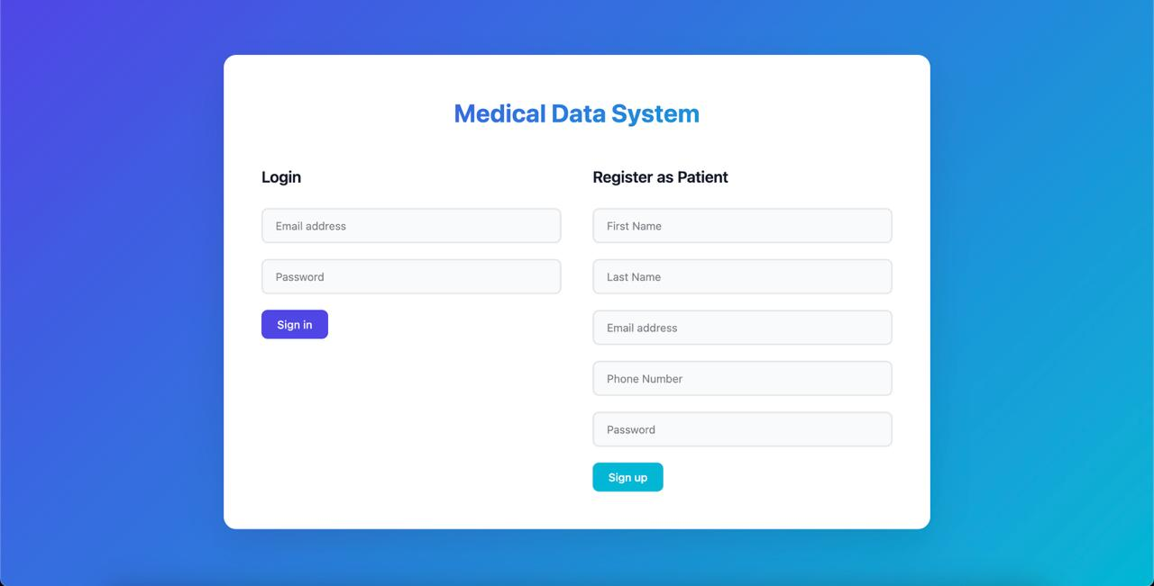
Figure 1. Sign in form.

Prototype Development
Prototype developed using Figma following Design Science Research (DSR) methodology [27]. Design based on survey findings and security requirements identified in literature review.
The prototype was designed with security-first architecture where all data flows are encrypted and access is controlled by blockchain permissions. Transparency is ensured through visible audit trails and transaction history, while patient control is implemented via consent mechanisms aligned with GDPR/HIPAA requirements. The system maintains interoperability through FHIR-compliant data structures and prioritizes usability with intuitive interfaces suitable for non-technical medical staff.

  - Validity and Reliability
The study ensured content validity by basing survey questions on validated constructs from prior blockchain adoption and healthcare trust research [20]–[22]. Face validity was established through expert review by faculty members and healthcare IT specialists who assessed question clarity and relevance. Triangulation was achieved by combining survey data with prototype design evaluation, providing comprehensive findings from both quantitative and qualitative perspectives. The primary limitation is the small sample size (n=21), which restricts generalizability; therefore, findings are considered exploratory and hypothesis-generating rather than conclusive.

Results
This section presents the findings from the quantitative survey distributed across four stratified respondent groups—cybersecurity students, cybersecurity professionals, medical students, and medical professionals—and the qualitative software design prototype developed to visualize the proposed hybrid permissioned blockchain system.
  - Survey results
The survey collected 21 responses across four stratified groups—cybersecurity students (n=5), cybersecurity professionals (n=5), medical students (n=5), and medical professionals (n=6)—to assess differences in awareness, perceptions, and acceptance of permissioned blockchain systems for secure healthcare data exchange. This section presents a comparative analysis of key findings, highlighting domain-specific and role-based differences in attitudes toward blockchain security, privacy, and feasibility.
Cybersecurity Domain
Both cybersecurity students and professionals demonstrated high confidence in permissioned blockchain architectures for healthcare data exchange, though with notable differences in priorities and operational focus. Among students, 60% agreed and 40% strongly agreed that they understood the difference between permissioned and permissionless blockchains, while professionals showed stronger conviction: 80% agreed or strongly agreed that permissioned blockchain is appropriate for secure medical data exchange, compared to 60% of students who believed it could enhance privacy over traditional databases. This difference suggests that theoretical understanding (students) translates into stronger applied confidence (professionals) after practical exposure to blockchain deployments.
When evaluating security challenges, students and professionals identified different priorities reflecting their respective positions in the educational-to-operational pipeline. Students emphasized compliance with GDPR/HIPAA (60%) and smart contract vulnerabilities (60%), reflecting academic focus on regulatory frameworks and code-level security. In contrast, professionals prioritized role-based access control (RBAC) (40%) and data anonymization/pseudonymization (20%), indicating operational concern with authentication mechanisms and privacy-preserving techniques in production environments. Students also identified the greatest cybersecurity risks as smart contract exploitation and data interception during transmission (both 60%), while professionals focused on implementing layered defense mechanisms including RBAC, encryption, and multi-factor authentication.
Educational preparedness emerged as a critical theme among students, who identified simulation of blockchain attack scenarios (100%) as the most effective preparation method, followed by cryptography and distributed systems courses (60%) and Capture The Flag competitions (40%). This demand for hands-on, scenario-based training underscores a gap between theoretical blockchain education and practical security implementation skills, aligning with contemporary cybersecurity pedagogy that emphasizes experiential learning.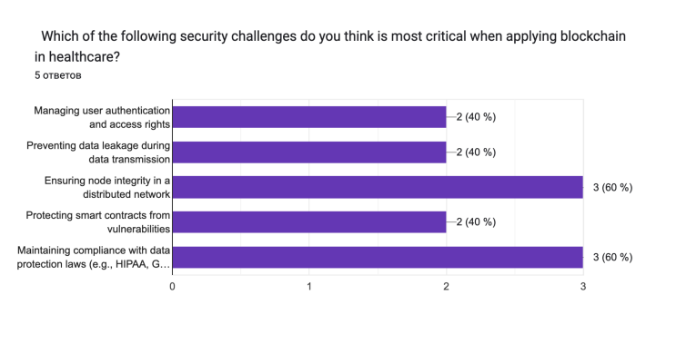Figure 2. Most critical security challenges.
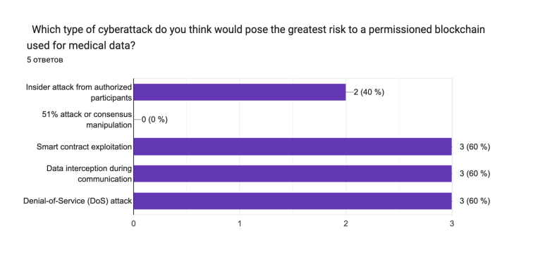
Figure 3. Greatest perceived cyber risks.
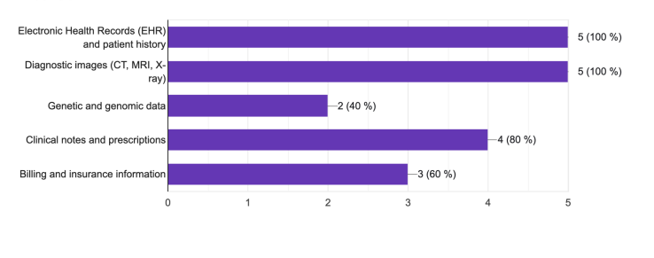
Figure 4. Critical medical data to protect.

Medical Domain
Medical students and professionals demonstrated convergent awareness of data security risks but divergent perspectives on privacy-usability trade-offs and implementation priorities. Both groups recognized data breaches and unauthorized access as critical threats: 80% of students identified these as among the most serious problems in digital healthcare systems (with 40% strongly agreeing), paralleling professionals' assessments, though only 50% of professionals expressed confidence in current institutional security measures. This gap suggests that awareness does not translate to trust in existing safeguards.
A notable difference emerged in attitudes toward prioritizing privacy over system efficiency. Medical students showed strong idealism: 80% agreed or strongly agreed that patient privacy should be prioritized even if it slows data access, reflecting patient-centered values common in early-stage medical education. In contrast, medical professionals demonstrated more pragmatic views, with only 66.6% agreeing and 33.3% remaining neutral or skeptical. This divergence indicates that clinical experience introduces operational considerations around workflow efficiency, time-sensitive care delivery, and the practical constraints of high-volume healthcare environments.
Both groups supported patient-managed consent mechanisms, though with different emphases. Students (60% agree or strongly agree) viewed patient-controlled access via digital consent or smart contracts as enhancing transparency and ethics, while professionals (66.6% agree or strongly agree) emphasized operational efficiency—specifically, reduction of administrative workload and consent-related errors. This convergence validates the proposed hybrid architecture's patient consent module as addressing both ethical imperatives and practical workflow concerns, making it acceptable across medical stakeholders with varying priorities.
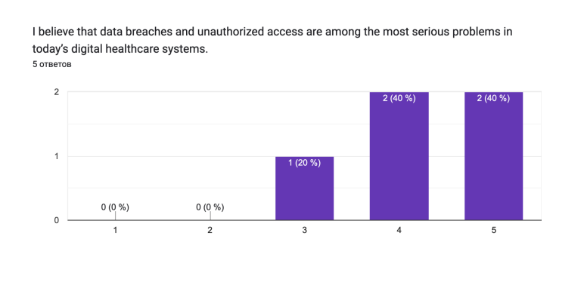Figure 5. Data breaches as a serious problem.
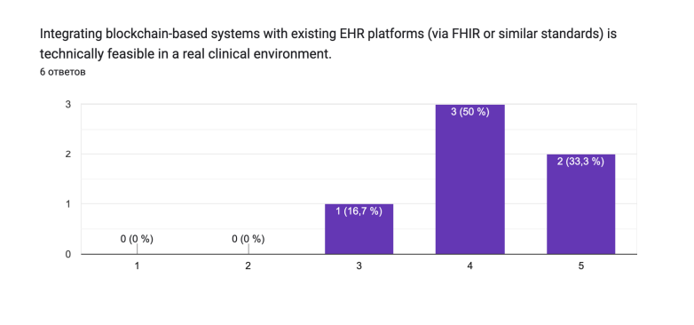
Figure 6. Feasibility of EHR–Blockchain integration.
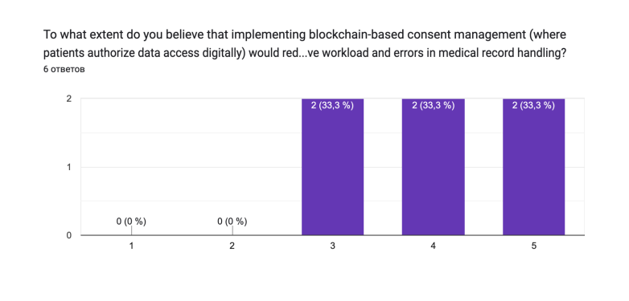
Figure 7. Blockchain-based consent efficiency.

  - Software Implementation
The hybrid permissioned blockchain architecture integrating Hyperledger Fabric and Corda with FHIR middleware was implemented as a functional prototype addressing core requirements: regulatory compliance (GDPR/HIPAA), EHR interoperability, patient-controlled consent, and role-based access control.
The system comprises seven layers: Patient Application Layer (secure records and consent management), FHIR Gateway API (EHR compatibility), HSM/KMS (cryptographic key storage), DID/Identity Registry (decentralized identity), Hyperledger Fabric Network (multi-institutional coordination), Off-chain IPFS Storage (encrypted files with on-chain hash verification), and Corda Network (bilateral confidential transactions). This design enables selective visibility: Fabric channels support consortium collaboration while Corda ensures sensitive data remains accessible only to authorized parties—directly addressing survey findings where 100% of cybersecurity professionals and 80% of medical students prioritized data privacy and protection.
Frontend implementation (HTML, CSS, JavaScript) includes: Authentication Module with JWT-based RBAC (addressing 80% cybersecurity professionals' priority), Dashboard with real-time network metrics (94% respondents prioritized auditability), Data Transfer Interface with AES-256 encryption and immutable activity logs, and Patient Consent Panel enabling selective authorization by data category with real-time revocation—directly validating 60% medical students' and 66.6% medical professionals' support for patient-controlled access.
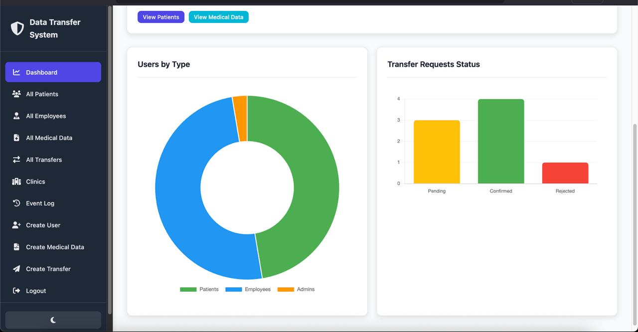
Figure 9. Dashboard.
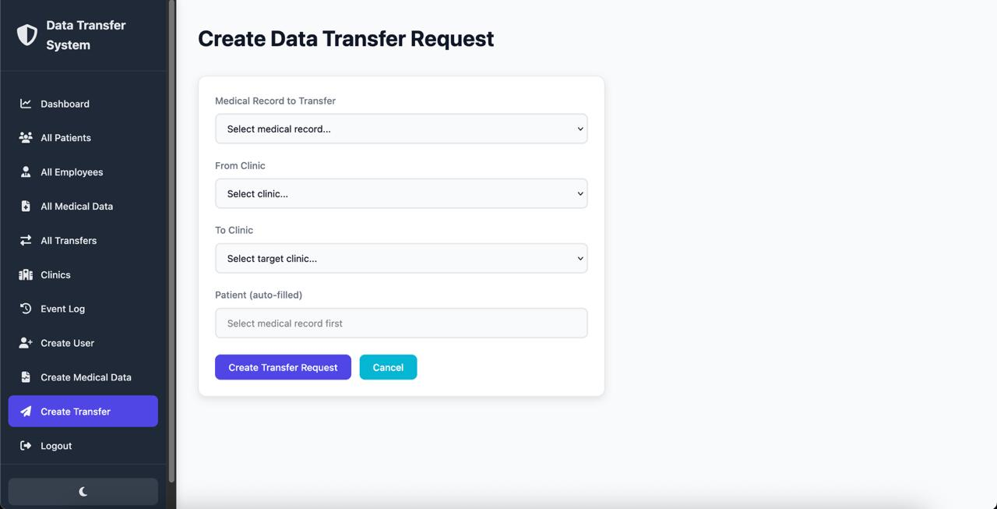
Figure 10. Data Transfer.
The Security and Compliance Center monitors GDPR/HIPAA adherence with real-time status indicators, addressing 83.3% of medical professionals' concern about regulatory uncertainty. Admin Management Panel provides granular access controls and node governance, validating 40% cybersecurity professionals' priority for layered defense mechanisms.

Discussion
This study presented a hybrid permissioned blockchain system for secure medical data exchange, combining Hyperledger Fabric and Corda with FHIR integration to comply with GDPR and HIPAA standards. Survey results showed strong support from both cybersecurity and healthcare professionals, highlighting the relevance and demand for the proposed architecture. High levels of trust in patient consent management and access control mechanisms indicate the practical applicability of the system in clinical settings.
The findings revealed different priorities between students and professionals, as well as between cybersecurity and medical experts, suggesting that a multidisciplinary approach is essential when designing and implementing such systems. The proposed architecture effectively balances privacy, efficiency, and scalability, addressing longstanding issues in centralized EHR systems, such as data breach vulnerabilities and lack of interoperability.
A limitation of the study is the small sample size (n=21), which restricts broad generalization of the results. However, the mixed-methods structure provides sufficient analytical depth to generate hypotheses for future research. Future work will focus on larger-scale empirical evaluations and integration with real-world clinical information systems to assess practical performance and reliability.
Overall, these results demonstrate the potential of hybrid permissioned blockchain systems to transform medical data management, offering increased protection and convenience for all stakeholders in the healthcare ecosystem.

Conclusion
This research confirms that a hybrid architecture combining Hyperledger Fabric and Corda can significantly enhance the security, scalability, and interoperability of medical data exchange systems. The proposed approach ensures rigorous access control, patient consent management, and compliance with critical regulatory frameworks such as GDPR and HIPAA.
Key findings indicate that this system minimizes risks of data leakage and duplication, improves transparency, and fosters trust among both medical and cybersecurity professionals. At the same time, observed differences in participant perspectives underscore the importance of addressing the diverse requirements and interests of various stakeholder groups in digital healthcare solution design.
It is recommended that future research explores further scaling and integration of the proposed system into existing healthcare infrastructure and investigates user experience and legal aspects in greater depth. Overall, this work makes a significant contribution to the application of blockchain technology in medicine and provides a foundation for further innovation in sensitive medical information management.

References
[1] M. Hasnain, F. R. Albogamy, S. S. Alamri, I. Ghani, and B. Mehboob, “The Hyperledger Fabric as a Blockchain Framework Preserves the Security of Electronic Health Records,” Health Informatics J., vol. 29, no. 4, pp. 1471–1488, 2023.
[2] P. Kasyapa, “Blockchain Integration in Healthcare: A Comprehensive Investigation,” Front. Digit. Health, vol. 2, p. 1359858, 2024.
[3] Z. Zhang and D. Wei, “Unleashing the Potential of Permissioned Blockchain—Addressing Privacy, Security and Interoperability Concerns in Healthcare Data Management,” Electronics, vol. 13, no. 24, p. 5050, Dec. 2024.
[4] P. Katoon, “Interoperable Blockchain Network for Healthcare Data Using Hyperledger Fabric and Ethereum,” J. Health Inf. Res., vol. 1, Art. no. 00564, 2025.
[5] World Bank ITS Technology & Innovation Lab, The Case for Blockchain Interoperability, 2023.
[6] S. Shabani and A. Thorogood, “Dynamic Consent Using Blockchain Technology,” Genet. Med., vol. 26, pp. 120–131, 2024.
[7] A. A. Siyal, A. Z. Junejo, M. Zawish, K. Ahmed, A. Khalil, and G. Soursou, “Unleashing the Potential of Permissioned Blockchain: Addressing Privacy, Security, and Interoperability Concerns in Healthcare Data Management,” Electronics, vol. 13, no. 24, p. 5050, 2024.
[8] P. Gupta, N. M. El-Gohary, and S. Kim, “hChain 4.0: A Permissioned Blockchain Architecture for Smart Healthcare Data Management,” arXiv preprint arXiv:2505.13861, 2025.
[9] Y.-P. Lin, D. C. Yen, and S.-W. Wang, “Efficient Clinical Data Sharing Framework Based on Blockchain Technology,” J. Med. Syst., vol. 45, no. 6, pp. 1–13, 2021.
[10] R. Kumar, N. Marchang, and R. Tripathi, “Permissioned Blockchain Approach Using Open Data in Healthcare,” Procedia Comput. Sci., vol. 210, pp. 584–593, 2022.
[11] A. Azaria, A. Ekblaw, T. Vieira, and A. Lippman, “ACTION-EHR: Patient-Centric Blockchain-Based Electronic Health Record Data Management for Cancer Care,” J. Med. Internet Res., vol. 22, no. 8, p. e13598, 2020.
[12] M. Shabani and A. Thorogood, “Distributed Management of Patient Data-Sharing Informed Consents for Clinical Research Using Blockchain,” Front. Digit. Health, vol. 6, p. 1381216, 2024.
[13] Y. Zhuang, L. R. Sheets, Z. Shae, J.-J. P. Tsai, and C.-R. Shyu, “Applying Blockchain Technology for Health Information Exchange and Interoperability: Systematic Review,” J. Med. Internet Res., vol. 22, no. 7, p. e17199, 2020.
[14] D. M. Maslove, J. Klein, and J. M. Brophy, “A Blockchain Framework for Managing and Monitoring Data in Multi-Site Clinical Trials,” arXiv preprint arXiv:1902.03975, 2019.
[15] “Stratified Random Sampling Explained,” Theysaid, 2025. Online. Available: https://www.theysaid.io/blog/stratified-random-sampling-for-researchers
[16] “Stratified Sampling: A Comprehensive Guide,” SurveyLab, 2024. Online. Available: https://www.surveylab.com/blog/stratified-sampling/
[17] I. Etikan and K. Bala, “Sampling and sampling methods,” Biometrics & Biostatistics International Journal, vol. 5, no. 6, pp. 215–217, 2017. doi:10.15406/bbij.2017.05.00149
[18] “Independent vs. Dependent Variables | Definition & Examples,” Scribbr, 2023. Online. Available: https://www.scribbr.com/methodology/independent-and-dependent-variables/
[19] M. A. Bazel, R. N. Nagarajan, and S. Subramanian, “Blockchain technology adoption in healthcare: Factors influencing providers’ intention,” Sci. Rep., 2025.
[20] P. Esmaeilzadeh, “The potential of blockchain technology for health information exchange: Experimental study from patients’ perspectives,” J. Med. Internet Res., vol. 21, no. 6, p. e14184, 2019.
[21] H. Treiblmaier, S. Rejeb, and K. Strebinger, “Harnessing blockchain to transform healthcare data governance and patient empowerment,” Front. Med., vol. 11, 2024.
[22] P. Zhang, J. White, D. C. Schmidt, G. Lenz, and S. T. Rosenbloom, “FHIRChain: Applying blockchain to securely and scalably share clinical data,” Comput. Struct. Biotechnol. J., vol. 16, pp. 267–278, 2018.
[23] “What Is a Likert Scale? | Guide & Examples,” Scribbr, 2023. Online. Available: https://www.scribbr.com/methodology/likert-scale/
[24] G. Norman, “Likert scales, levels of measurement and the ‘laws’ of statistics,” Advances in Health Sciences Education, vol. 15, no. 5, pp. 625-632, 2010. Online. Available: https://www.ncbi.nlm.nih.gov/pmc/articles/PMC3886444/
[25] “Types of Variables in Research & Statistics | Examples,” Scribbr, 2023. Online. Available: https://www.scribbr.com/methodology/types-of-variables/
[26] J. W. Creswell and V. L. Plano Clark, Designing and Conducting Mixed Methods Research, 3rd ed. Thousand Oaks, CA, USA: Sage, 2018.
[27] A. R. Hevner, S. T. March, J. Park, and S. Ram, “Design science in information systems research,” MIS Q., vol. 28, no. 1, pp. 75–105, 2004.
[28] E. Davies, M. Astudillo, and P. Dinh, “Evaluating Go for High-Concurrency Web Services: Performance and Security Analysis,” IEEE Access, vol. 12, pp. 98765–98778, 2024.
[29] L. Castro, J. Morgan, and F. Mahoney, “Security and Encryption in PostgreSQL for Sensitive Data Applications,” Comput. Secur., vol. 130, p. 103471, 2023.
Github repository: https://github.com/axmdl1/MedicalDataExchange.git

